**Bryn Loftness**

**Essay**

**2-D Art – Final Project**

Through the collection of my thirty images, I found that I have a visual preference for human body figures and organic line drawings. I was specifically drawn to eyes, lips, faces in general, and naked body figures. I also had a visual preference for high-key warmer colors mixed with lots of neutrals, thus creating a lot of emphasis on certain small detailed aspects of the pieces and created focuses on meticulous/smaller details that might go unnoticed. I also found a lot of images consisted of red, blue, white, and black. A lot of my images were minimalistic, and detail based, using the concept of economy overwhelmingly. The depth in my images were created through color contrast in the bodies and not usually the backgrounds going back in space, due to my lack of landscape images. Generally, I feel the images I chose largely reflect my personality and general emotional state.

As I previously stated, I showed interest in human body figures as well as organic line drawings. I find that I am very drawn to high detail, but still simple line-drawing pieces, such as Image 7, 8, 10, and 12. You can also see my high preference for the female human body. I find that the female form is one of the most inspirational and rousing in others’ work as well as the art that I create. I also feel many of the pieces I chose can be generally described as thought-provoking, as in they don’t necessarily immediately give off the artists underlying meaning or message. They are largely up to interpretation.

I felt that my images composition specifically represented the artistic concept of economy and simplicity. The pieces I selected really got rid of all non-essential/unimportant elements and details which didn’t contribute to their essence of what was supposed to be pictured/focused upon. The style of minimalism intrigues me. Focal points of my pieces were generally centrally located with few leading lines, they were prominent without any directional forces. Examples of the prominent, unmistakable focal points can be found in Images 2, 6, 9, and 24. Leading lines however were used occasionally in backgrounds such as the repetition in Image 15.

A lot of my images were rather flat. I didn’t have a lot of images showing landscapes or distance other than Image 1, 18, and 24. The depth of my images was mostly created though overlap, contrast, and color-shading giving the 3-d perspective to the human body figures. I found that I prefer the one-dimensional aspect of line drawings and the elegance that they create. The landscapes and backgrounds were often solid colored or simple repetitious designs such as in Image 6 and 15.

Continuing upon my interest of line drawings in relation to color choices, I also showed preference for images with small additions of color that added emphasis. This pattern can be seen in Image 20, 3, and 9. The small bits of bright, warm, high key colors created contrast that I found to be intriguing and very non-overwhelming. Sometimes I find that images with too much color can over-excite my eyes and leave me feeling overwhelmed. That’s why I can see a lot of my images have a good balance of dark to light and high-key to lowkey; rarely with additions of bright colors other than Image 18 and 19. Those images however, were simple and left me comforted rather than overstimulated.

I decided on the women because my photos depicted humans and human bodies most predominantly. I got inspiration for the bottom portion for my piece from the hands in image 22 and 23. I took the background from image 15, and the flower-theme from image 17 and 28. The focal point in my piece is the woman, and more specifically, her face. I drew the viewers eye to the focal point with directional lines in the background leading to her body, and specific unique colors-like the blue eyes- to emphasize the focal-region of the piece. The green of the hands on the bottom are supposed to lead to the green nose and the blue directional lines in the background should lead to the blue in the eyes. The red and yellow from the lips should correspond with the red, yellow, and orange of the flowers. The colors are my main tool in drawing my viewer around to the different aspects of the piece. To show depth I will be overlapping features, like the flowers and the hands, as well as dulling colors in the background and away from the face to bring emphasis to the focal point.

**Bryn Loftness**

**Image Analysis**

**2-D Art – Final Project**

Image 1:

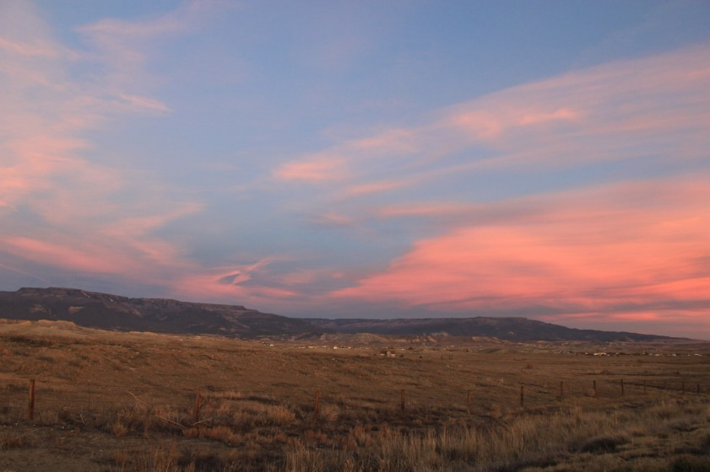

**Imagery**

Medium: Photo

Imagery: Realist, Nature,

Shapes: Free-flowing clouds and organic/non-geometric mountains

**Compositional Preferences**

The clouds are kind of leading your eyes throughout the image and directing focus and emphasis towards the mountains. The balance is asymmetrical because the horizon line is lower in the image. The stretches of clouds kind of create leading lines across the image to lead the eye across the sky

**Depth**

Lower Horizon Line to emphasize sky and clouds as focal point. Darker mountains in background create distance and depth within image. The sky also gets darker as you approach the horizon line, thus creating depth.

**Color**

The toned-down, low saturation, colors of the bottom half of the image allows the focus to be drawn to the sky and clouds; which are vibrant and attention-drawing.

Image 2:

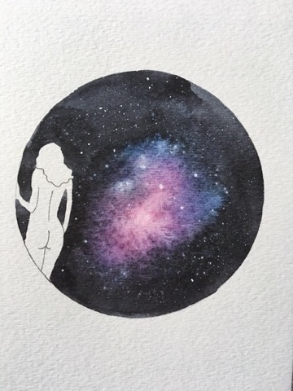

**Imagery**

Medium: Painting/Mixed Media, watercolor with ink

Imagery: Realist, Nature, People

Shapes are mostly the organic woman and organic space enclosed in the geometric circular orb.

**Compositional Preferences**

The focal point- the woman- is defined using the Negative shape of the human within the “orb” of dark space. There is asymmetrical balance in this piece because there is nothing really weighing down the other side of the image opposite of the woman. There is high contrast between the background, the orb of space, and the woman. The woman is isolated, thus creating emphasis through separation.

**Depth**

The direction of the body looking outwards and back, seemingly into space, creates depth in the image. Other than the feature of the woman, the image is primarily flat in space (literally haha). The tangent of the women touching the outside of the orb creates visual tension and intrigue as well as flattens the image.

**Color**

Dark Contrast Pattern. The temperature is cooler, with low saturation. Emphasis is created through standout colors being the primary background with the addition of the neutral figure, thus creating emphasis on the figure.

Image 3:

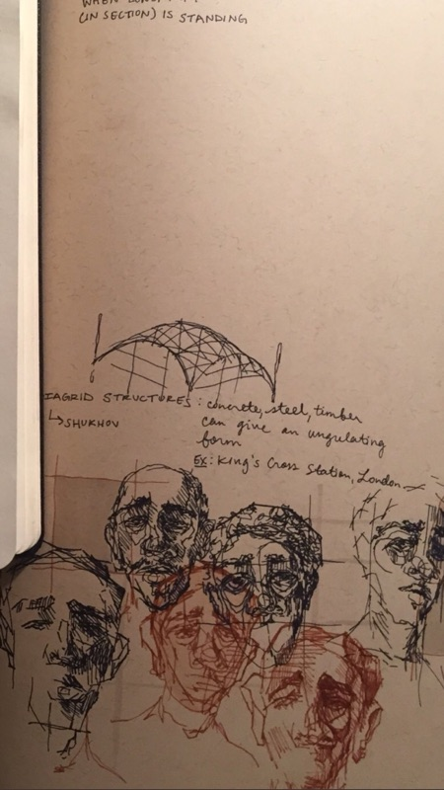

**Imagery**

Medium: Ink on paper

Imagery: Geometric, People, Faces

Shapes are mostly the people, whom are less organic and more geometric/rigid in style

**Compositional Preferences**

The balance is symmetrical; there are two humans on the outskirts/sides. One whom is in the front-ish and another that is towards the back with 4 humans in the middle in a sort of diamond pattern. There is repetition in the image based on the 5 humans. There are no other main focuses of the piece other than the faces.

**Depth**

The human in the upper left is depicted to be farther back because of the decrease in detail and boldness. He also overlaps with the back edge, thus making it seem he is getting lost in the back of the image- not the focal point. Though he is not the focal point, there is emphasis brought to the man in the back because of the isolation based on separation.

**Color**

There is no clear focal point other than the two humans in the red shade rather than the 4 in black. The two in red are emphasized because of their distinct hue compared to the black. It also creates balance and visual intrigue adding the two different colors.

Image 4:

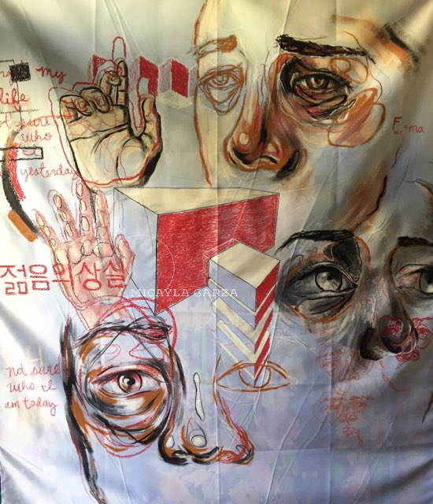

**Imagery**

Medium: ink/drawing, paint

Imagery: Geometric, People, Organic, Hands, Faces

Shapes are pieces of faces, some writing/lettering, hands, and geometric buildings

**Compositional Preferences**

I think that the focal point is the human looking straight at the viewer, however the geometric building in the center also draws my interest. I felt the gaze of the other two faces led me out of the image rather than towards it, so I didn’t consider those to be points of focus. Most of the image is centered around the upper two quadrants of the image, leading you slowly up and back down the piece.

**Depth**

You can tell that the 3rd human, the one most towards the center of the right edge of the piece is farthest back because it is darker, has less bright colors, and is not as detailed as the other parts of the piece. There is also depth being created through the top human face with the side of the face that is supposed to be farther away being less detailed, less colored, and more dull.

**Color**

Distinct colors are: Black, Orange, Cream, and Yellow. These colors are all on one half of the color wheel -other than black- so it is therefore an analogous color scheme and are primarily warm. There is high saturation and intensity within the juxtaposition of whites in the eyes to the darker colors surrounding them and highlight them. The artist of this piece uses contrast of color and saturation to really emphasis different aspects of the piece, leaving other-less important parts- dull, less detailed, and dark.

Image 5:

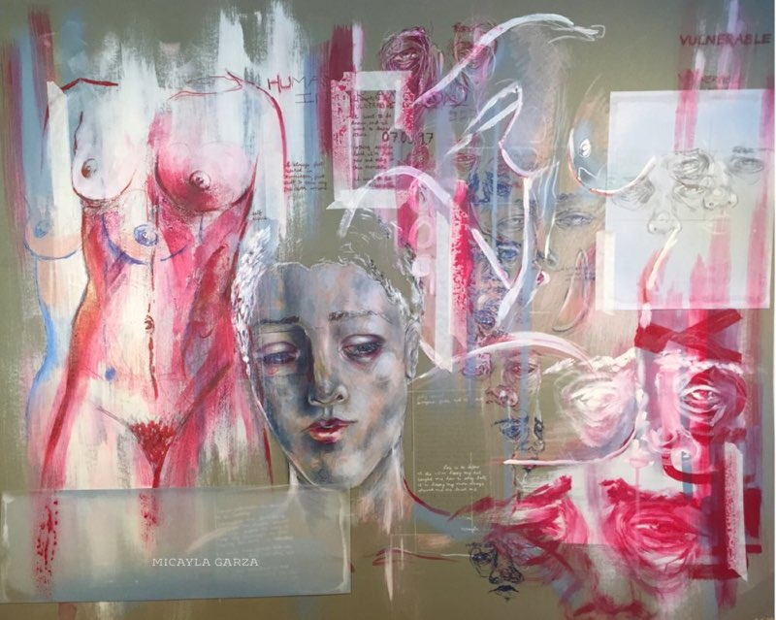

**Imagery**

Medium: Paint, ink

Imagery: Geometric, People, faces, bodies, realistic, abstract

Shapes are the body figures, some which are more discrete than others, and some geometric shapes

**Compositional Preferences**

The focal point is the woman’s face, which is the most detailed and color-shaded aspect to the piece. It draws the viewer to the different corners of the piece, starting at the lightly colored body figure next to her. There is emphasis in the amount of detail she puts into specific aspects; such as the detailed and colored female body figure juxtaposed against the white outlined figure to her right.

**Depth**

The piece is mostly flat other than the roundness of the bodies and figures. There is some overlapping which creates depth, but it doesn’t seem to be going back into space. There are differentiations in scale, but it doesn’t seem to represent depth. Overlap is used primarily on this piece, layering the different portions and figures within the image.

**Color**

Primary colors are Red, white, and blue which creates a primary triad color scheme. There are various tints and shades added to create depth and life-like aspects to the different parts of the piece. The piece is highkey with high saturation reds bringing out different focuses of the artwork.

Image 6:

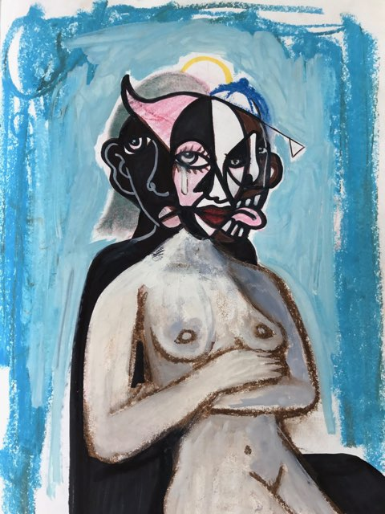

**Imagery**

Medium: Painting

Imagery: People, faces, bodies, realistic, slightly abstract looking

Shapes: the body figures and the geometric shapes within the head

**Compositional Preferences** (How are they creating Visual Interest with focal points, emphasis, balance, directional forces, unity, movement, variety?):

The focal points are the faces, specifically the most upfront figures face. Emphasis is brought to the face because of the inclusions of bursts of color and detail. Including the pink, yellow, and darker blue.

**Depth** (What kind of depth? How is it being created?):

Depth is created because objects farther back on the page are usually darker and less detailed, and this is the case with the shadowed figure in the back. The shadowed figure is also being overlapped, thus implying it is behind the forefront figure. There is no background/landscape so color depth is really the only depth included in the piece.

**Color**

Color balance is created within the two figures with one being so lightly colored and the other being darker, like the antithesis of the figure in the front. The main colors are blue, pink, grey, brown, black, and white. The colors are not high key, all seem to be mixed with some tints and shades- like the background being a lighter blue and lips being a darker red. This image slightly resembles a primary triad.

Image 7:

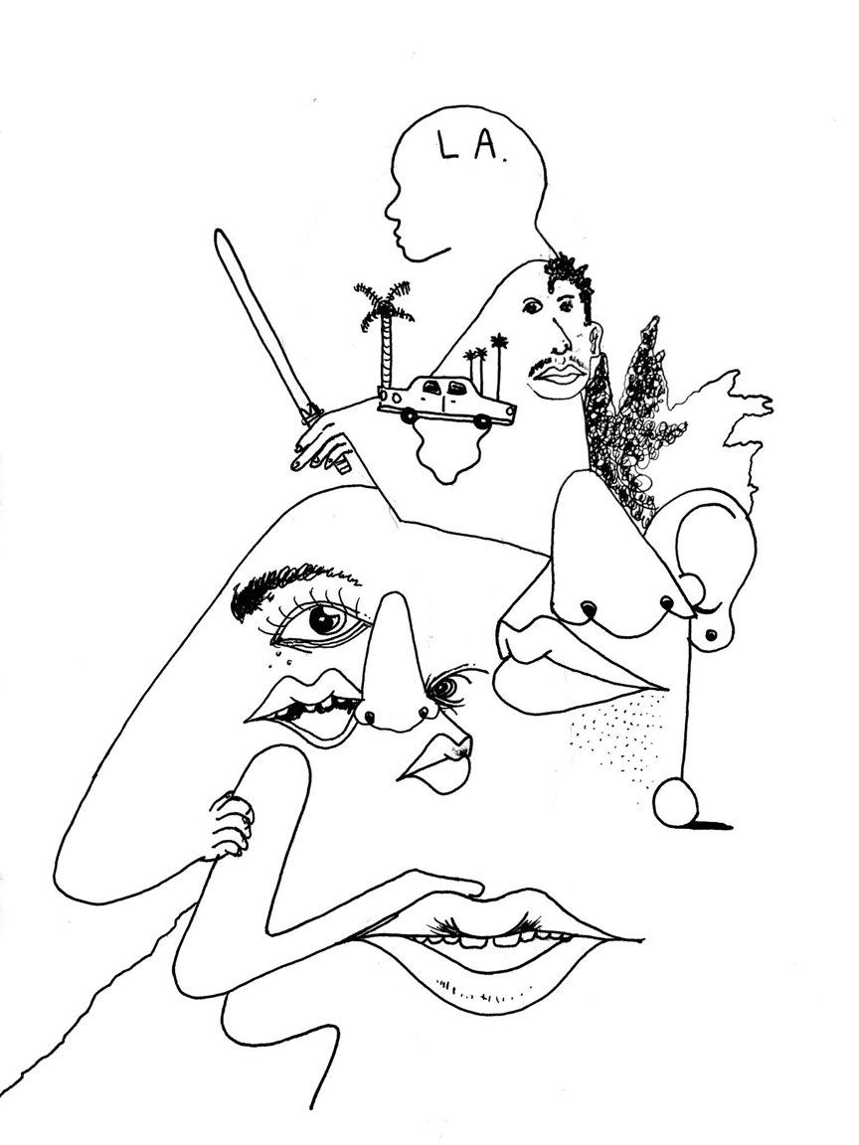

**Imagery**

Medium: Line Drawing of ink

Imagery: Realist, Expressive, Human, Eyes

Shapes: Lines and various geometric/organic shapes creating abstract-looking human features and small details like the car and palm tree.

**Compositional Preferences**

The focal point is a little hard to distinguish, but I think it’s the car and dude on the top. There are directional lines creating movement leading from the bottom right corner of the piece up to the top, which has the most contrast and details. There is emphasis within this region because of this. Balance is created because on the bottom a lot of the details are widely spread and not dark and, on the top,, they are condensed but still spread. The contrast is slowly increased within the lines. This also creates unity.

**Depth**

Depth is not a huge aspect of this piece. There is a lot of use of overlaps and tangents, but not a lot of objects going back in space. There are smaller objects which can be taken that they are farther back in the image, but it is not clear if that is the case or if that is just for visual appeal.

**Color**

The color scheme is achromatic, with just black and white. The spread out, lighter bottom is contrasted with the more condensed, darker/more contrasted top thus creating color balance.

Image 8:

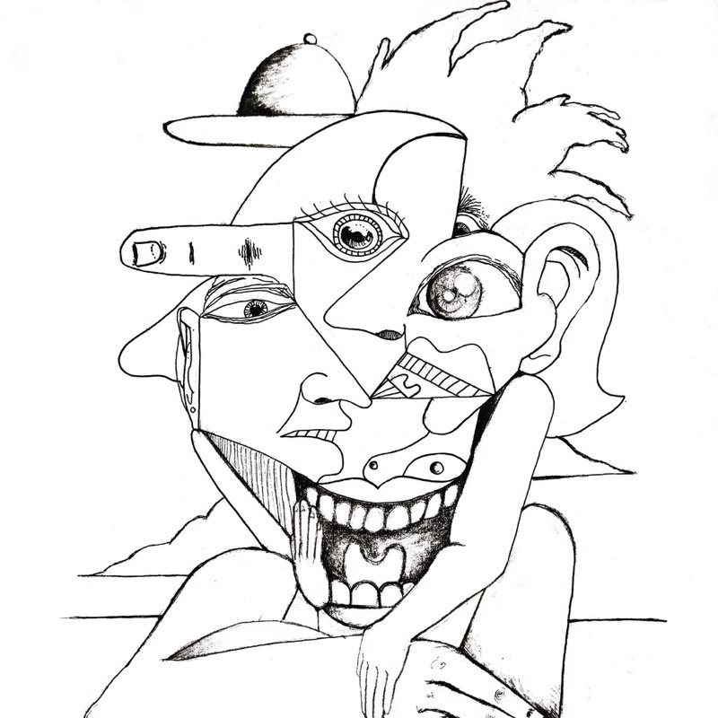

**Imagery**

Medium: Line Drawing of ink

Imagery: Realist, Expressive, Human,

Shapes: Lines and various geometric/organic shapes creating abstract-looking human heads.

**Compositional Preferences**

The focal point is the three eyes in the middle of the image. They have the most detail and are the main pieces of the three divisions within the piece. The two faces on either side seem to be looking towards the center, which leads me to believe that the main focus is the eye highest on the page, the one looking straight forward. There is balance created in the completeness of the two additional faces that are looking in, they pull in the viewer and pull together the picture. The arms unify the picture from the bottom up.

**Depth**

Depth is not a huge factor in this image. There are several instances of overlap, but it is mostly for visual interest and not to show objects going back into space. There are cloud looking things in the back, but they are just overlapped and put smaller in the background, which subtly creates depth.

**Color**

The color scheme is achromatic, only using black and white and its various tints and shades. The shading helps create depth within the mouth and a 3d aspect to the eyes.

Image 9:

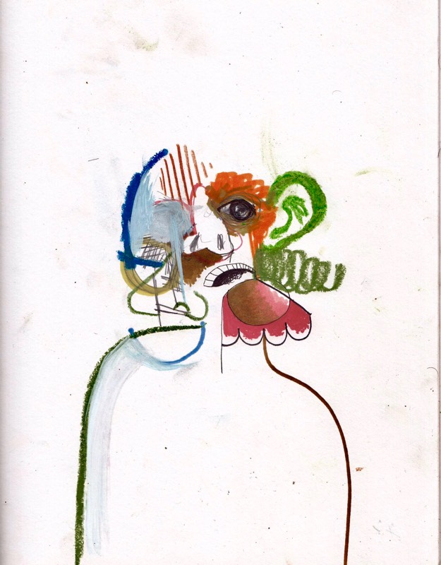

**Imagery**

Medium: Drawing/ Painting/Mixed Media

Imagery: Realist, Human, Abstract

Shapes: Different line widths and styles, abstract shapes, human body

**Compositional Preferences**

The focal point is the face. The rest of the image is generally dull and unfocused with no additions of color or line. Then, you have the body lines used as a sort of directional force leading to the face while also outlining the body. There is emphasis within the focal point because of all the contrasting line widths and styles and color contrast.

**Depth**

Depth is not a factor in this image. The background is white, and nothing is going back in space.

**Color**

Color is used as a tool to emphasize the focal point- which is the face. The colors used primarily are orange, green, red and blue, which is a tetrad and a double complement. The colors are mostly warm, high key, with high saturation.

Image 10:

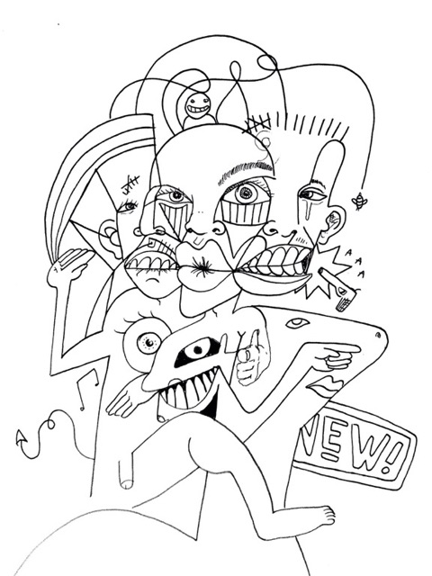

**Imagery**

Medium: ink

Imagery: Geometric, People, faces, bodies, abstract, line-drawing

Shapes are the body figures, faces, geometric shapes, and general doodles/squiggles

**Compositional Preferences**

The focal point for this piece is the center head. There are directional lines from the other two faces’ mouths and the directions of the eyes towards the center. Balance is created in the piece by the addition of the two faces on either side of the center face, looking towards the focal center. Unity is created by the addition of the doodles and squiggles along the edges of the piece, pulling it together and making it seem more whole. There is a lot of variety within the piece as well, which adds to the visual interest.

**Depth**

This image is primarily flat, because it is a line drawing. Depth tools such as overlap is used a lot as well as the two secondary faces are slightly smaller and directed diagonally away from the front, thus creating a sense of depth in that way. The effect of this is the front, primary face, seems more prominent and close.

**Color**

The color scheme for this image is achromatic; only black and white. All the lines are generally the same thickness. Color is not a major contributor to the visual interest of this piece.

Image 11:

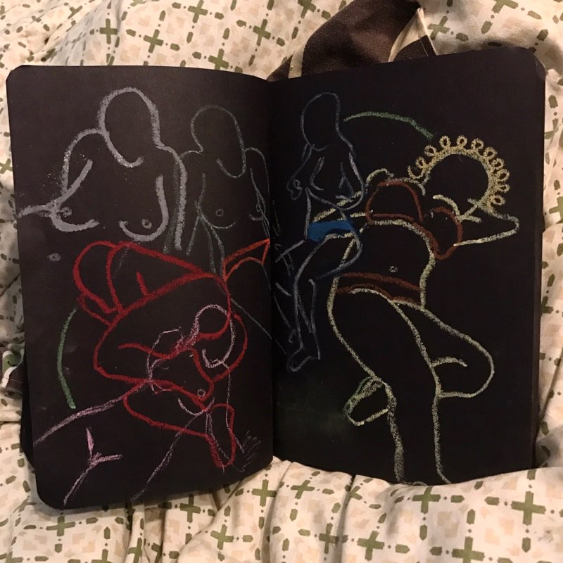

**Imagery**

Medium: chalk drawing on black paper

Imagery: People, bodies, realistic, line drawing

Shapes are the body figures/outlines

**Compositional Preferences**

The artist is creating visual interest by using a variety of line thicknesses and line colors. I would say the focal point for this piece is the women with the squiggly hair, just because she has the most detail and variety of color, however, it is not entirely clear. There is good balance in the piece because of the distribution of figures. There is a lowkey and an emphasized figure on the right side which evens out the three semi-emphasized figures on the left. This creates good unity through the repetition of figures.

**Depth**

This image’s aspects of depth are just tangents, overlaps, subtle atmospheric perspective for the two figures towards the back that seem to be farther away and have less contrast/are dull. The image is flat because it has a solid color background and does not go back into space except for other figures.

**Color**

The main colors in this piece are Red, Yellow, blue, and White. The color scheme is thus a primary triad. Since this is a line drawing with no background other than black, the colors really help distinguish different aspects of the piece, in this case it is the different figures, while also pulling it together because of the color scheme. It has good color balance because not too many colors are added.

Image 12:

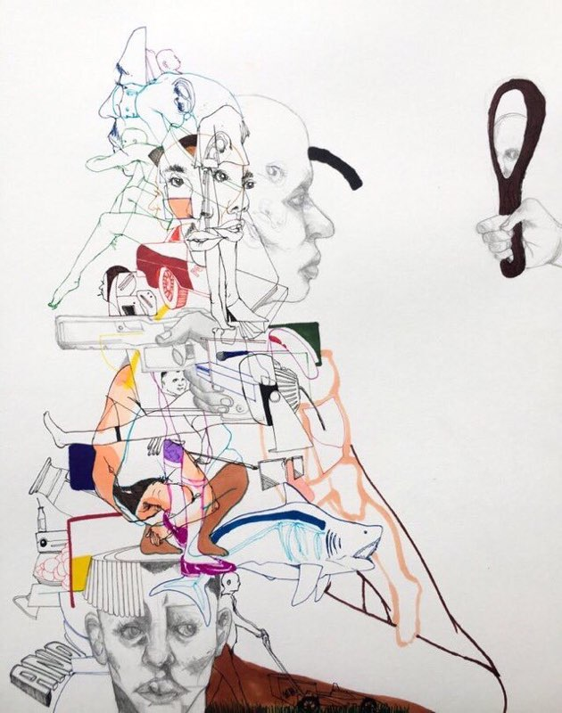

**Imagery**

Medium: Paint, ink

Imagery: Geometric, People, faces, bodies, realistic, abstract, line drawing

Shapes are the faces, some geometric objects, animals

**Compositional Preferences**

I believe the focal point of this image is the man looking in the mirror, however the emphasis is spread throughout the whole piece; it really draws the viewer in. The artist is creating visual interest through the asymmetrical balance. There is a lot happening in the right region of the piece but then leads the viewer to a large white space to its right. The eyes looking towards the mirror and the shark looking also two the right creates movement and leads the viewer towards that empty space.

**Depth**

Depth is created from the overlap and shading. You can see in the main face(the one looking at the mirror) the detail put into him showing the 3d aspect. There is not a lot of features going back into space or a background; most of the depth shown is just overlapping lines/object and tangents. The image is primarily flat

**Color**

The colors used in this piece are blue, cream, brown, yellow, and red. The inclusions of color are very subtle and thus creates visual interest and specific emphasis for the regions that do include color. The colors are all relatively warm and are pure in value, not a lot of tints and shades are added it seems.

Image 13:

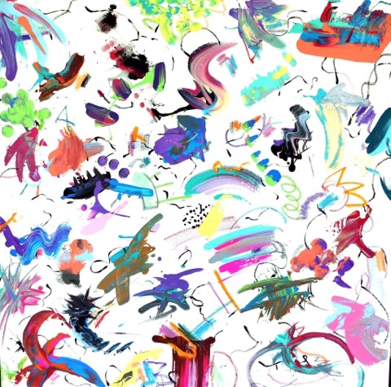

**Imagery**

Medium: Paint

Imagery: abstract

Shapes are abstract lines and squiggles

**Compositional Preferences**

There is no obvious focal point to me, my eye is just lead around the piece through the various lines and shapes created. There is good balance to the image, with one side or area never seeming too emphasized or focused upon.

**Depth**

Depth is not a factor in this image. It is abstract. There are instances of overlapping and tangents but they are not used as factors to create a 3-d space.

**Color**

The colors are all high key, high saturation colors. Color is the main aspect of this piece and there doesn’t seem to be a color scheme. Its very bright and vibrant which adds visual interest to the piece. It’s very abstract.

Image 14:

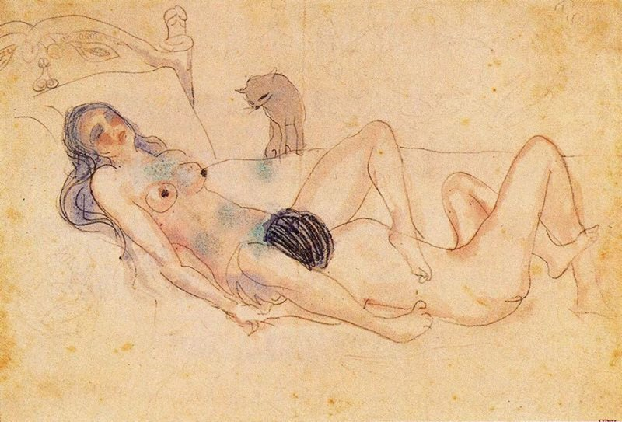

**Imagery**

Medium: Paint, ink

Imagery: People, faces, bodies, realistic, line drawing

Shapes are the body figures, the bed, and the cat

**Compositional Preferences**

The focal point is the woman. She is the most colored as well as has directional forces drawing the viewer to her; the cat is looking at her as well as the male’s hair creates contrast and lines leading the viewers eyes towards the woman. Balance is created because there are two figures, rather than just one, which automatically helps balance out the image.

**Depth**

Implied depth. It is being created by showing the bed going back into space on the top of the page, which implies it is farther away. The car is proportional to the size of the humans but is less detailed and less focused, so you can tell it’s farther away.

**Color**

The colors are all very lowkey and not high saturation. Color is not the primary aspect of this piece however they do draw emphasis to the focal point, which is the woman. The colors used mostly are red, blue, and yellow. It was a very lowkey primary triad.

Image 15:

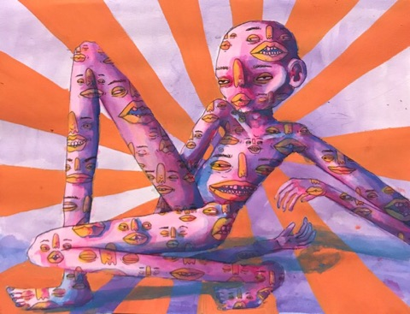

**Imagery**

Medium: Paint

Imagery: Geometric, People, faces, bodies, realistic(ish)

Shapes are the body figure, the faces on the body, and the geometric background

**Compositional Preferences**

The focal point of this piece is the face, upper chest of the body figure. You can see the background directional lines leads directly to this region and emphasizes the body as the significant point of the piece. There is balance created in the long limbs of the body and how they seem to stretch across the entire page. The repetition of faces throughout the body help to create unity through the variety of their facial expressions but similarity of color.

**Depth**

Depth is created in this piece through the shading of the body and limbs, as well as through the shadow of the body on the ground. You can see the artist has darkened the bottom half of the image, as to create a more 3d/room aspect.

**Color**

The colors in this piece is primarily orange, pink, blue. The colors are all pretty vibrant and the artist uses tints and shades to create color depth. The colors are high saturation but not very high key, they are definitely darkened and mixed before being put on the canvas.

Image 16:

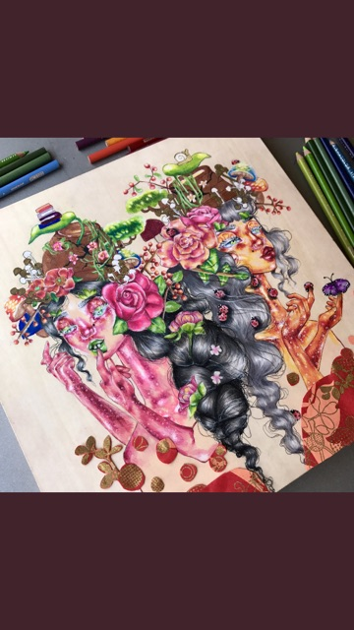

**Imagery**

Medium: Paint

Imagery: People, faces, bodies, realistic, floral

Shapes are the body figures, flowers, and the pots on their heads, generally organic

**Compositional Preferences**

The focal point of this image is the two faces. The flowers around the two faces frame the face and help to provide unity within the mess of detail and intricacy. There is balance in the piece because there is two figures and not just one. They are both looking outward which gives a sense of symmetry to the work.

**Depth**

The depth in this piece is created through the depth and the angles of the faces. There is also tons of overlap, which really defines the pieces’ complexity. The depth is implied depth of the figures and their bodies, but the background does not go back in space because it is solid colored.

**Color**

The colors used in this piece are all very high saturation, high intensity, high-key colors. The color selection really drives the different aspects/poritons of the piece. The major colors are pink, orange, green, brown, black, and grey. The repetition of the green in the pots on their heads as well as the brown on either sides of their body really contribute to the color balance of the piece and pull it the very busy piece together.

Image 17:

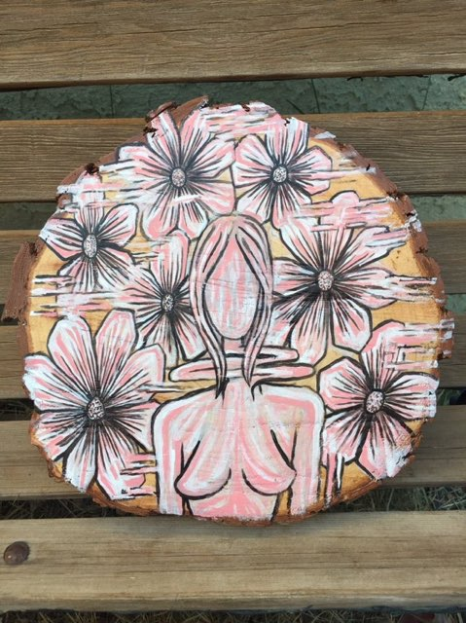

**Imagery**

Medium: Paint on wood

Imagery: semi-Geometric feel, People, faces, bodies, realistic, floral, line drawing

Shapes are the female body figure and the floral background

**Compositional Preferences**

The focal point of this piece is the female body. The repetitive flowers frame the figure and give a background for her; thus creating unity. The detail lines of color within the female also bring directional lines, leading you around the piece and throughout the female figure. The squiggles around the piece like in the neck and in some of the flowers bring variety and keep the piece interesting/ visually appealing.

**Depth**

Depth was created in the piece by adding shading to the body, giving it a rounder/3d aspect. There is no background that goes back in space, so the piece is flat looking.

**Color**

The main colors in this piece are pink, white, and black. The simplicity in the color scheme leaves a lot of the focus of the piece to be on the details. The colors are used, however, to create the color depth within the piece. The shading of the flowers and body help bring life to the objects and get them less flat.

Image 18:

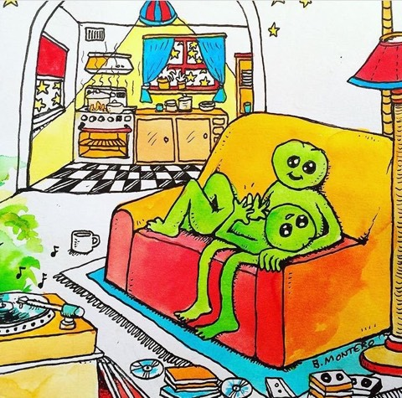

**Imagery**

Medium: Painting

Imagery: animals, faces, bodies, realistic, vibrant, expressive

Shapes are the features of the room, and the two frogs (the focal point)

**Compositional Preferences**

The focal point of the room is the two frogs in the couch chair. They are a bright green which provides emphasis on them and distinguishes them from the rest of the room. Balance is created because the front of the piece is generally spread out and simple while the back is farther away with less bright colors but is very detailed and condensed. You can see the movement that the artist tried to create in the laying down frogs’ hands moving like he’s explaining something, and the other frogs eye brows are raised like he’s listening just as attentively.

**Depth**

Depth is created in the room because it goes back in space. You can see the kitchen in the background is smaller and higher on the page, which implies its back in space. The record player is tangent to the front right bottom corner and is closer and larger towards the front which really places all the objects in the room and creates the well-rounded room depth.

**Color**

The colors used primarily are red, green, yellow, blue, and orange. Because of the wide range of high-key, high saturation colors in the room, the white in the room is really important to give the piece the color balance it has. The yellows in the front are more vibrant than the yellows in the back, which creates color depth.

Image 19:

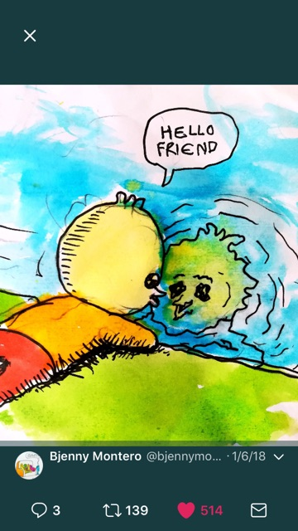

**Imagery**

Medium: Paint, Ink

Imagery: Animal, faces, bodies, abstract, relatively realistic

Shapes are the duck, the ground, and the water

**Compositional Preferences**

The artist creates visual interest in the focal point by making the image very expressive. You definitely get a sense of comfort from the piece, either because of it’s semi-childish appearance or its welcoming and soothing colors. The focal point in this piece is his face looking into the reflection and the reflection looking back. It has the most detail in the image and centrally located. His body acts as a directional force leading you to the reflection, as well as the lines surround the reflection framing it.

**Depth**

The depth created in the image is implied. There is depth within the water perceived because you can see his reflection in it and its slightly blurred/less clear. It also goes up the page which also implies it is farther away/back in space.

**Color**

The colors used primarily are yellow, green, orange, red, and blue, which provides a lot of balance because the color scheme is not limited just a few colors- it’s most of the colors of the rainbow. The colors in this piece are very high key and saturated.

Image 20:

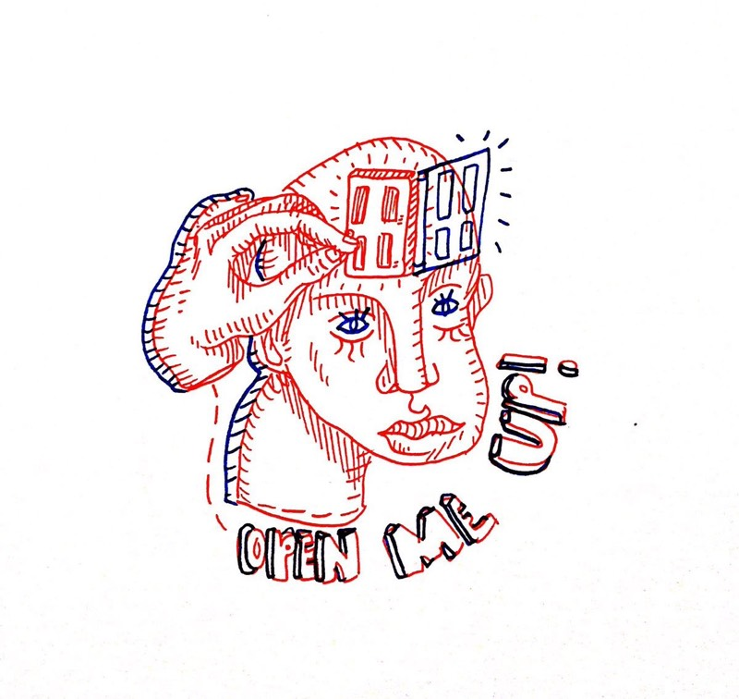

**Imagery**

Medium: ink

Imagery: People, faces, realistic, line drawing, hand, face

Shapes in this piece is the wording on the bottom, the geometric door, the face, and hand

**Compositional Preferences**

The focal point of this piece is, I think, the eyes facial region of the human. The hand, door, and lettering all seem secondary to the face and the eyes being blue provides a sense of contrast and emphasis to the viewer. The dotted lines leading from the hand to the lettering which wraps up to the door leads the eye around the piece and frames the central facial region.

**Depth**

Depth is created in use of blue, creating a sense of thickness to the hand, head, and lettering. However, the depth is not a rounded feeling, its more just a raised-off-the-page feeling. You can tell the door is being opened and thus creates depth.

**Color**

The primary colors of this piece are red and blue. Since this piece is a line drawing with a very small color scheme, the colors act together to provide emphasis to certain portions of the piece, ie the door. The colors differences of the blue specifically are also used to create color depth; in the boldness of the words and the thickness of head and hand primarily.

Image 21:

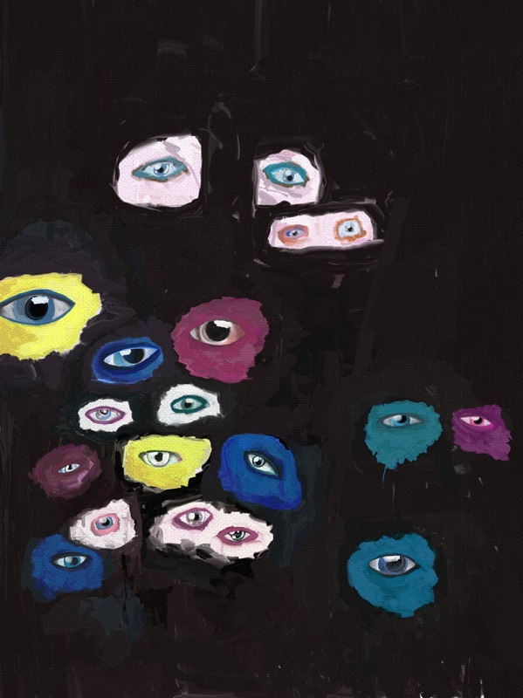

**Imagery**

Medium: Paint

Imagery: eyes, abstract

Shapes are the abstract blotches around the eyes and the eyes

**Compositional Preferences**

The focal points of this piece to me are just all the eyes, the focus is distributed among them. I don’t really see one that specifically sticks out. The dark background with the bright inclusions of color and seemingly random distribution of eyes draws the viewer in and provides a lot of visual interest. It also emphasizes the detail within the eyes to have the bright colors surrounding them.

**Depth**

Depth is not a significant feature of this piece. The black background could be considered darkness and therefore be eyes coming forward out of space, or it could just be a black background with eyes placed flat on top.

**Color**

The major colors used in this piece are *blue*, *burgundy*, white, *yellow*, and pink, and black. It is kind of a version of a primary triad, however the colors’ values have been altered with tints and shades. The repetition of colors help create balance among the eyes and create a sense of unity among them though there is a variety of colors.

Image 22:

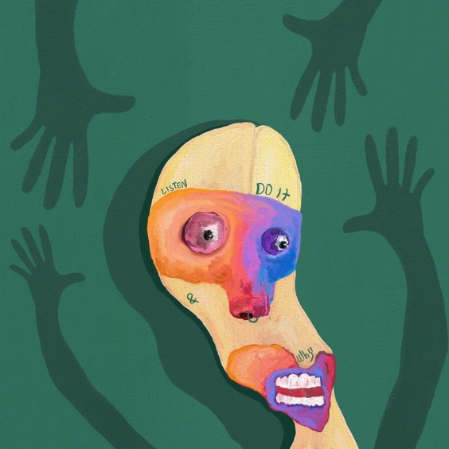

**Imagery**

Medium: Paint

Imagery: People, faces, abstract, hands

Shapes are the hands and the face with the geometric partitions on the face

**Compositional Preferences**

The artist creates visual interest in the focal point, which is the face, by including the most color and contrast here. It is emphasized because the hands seem to be framing the face, thus leading the eye there. There is balance created in the repetition and even number of hands on the page, everything seems to be very symmetrical and balanced.

**Depth**

Depth is created in the image from the shadow of the head and the darker hands. It looks like the hands are in the background or shadowed because they are the same color as the shadow of the head. There is not significant background in this image and the hands seem to be the only things placed back in space, but that is speculation, it is not entirely clear.

**Color**

The primary colors for this piece is orange, blue, red, and green, and yellow which thus creates a tetrad color scheme. The color on the face being split and slowly shaded from orange to blue helps to pull together the face while also separating it, as the piece seems to be trying to underlyingly show(the two sides to something).

Image 23:

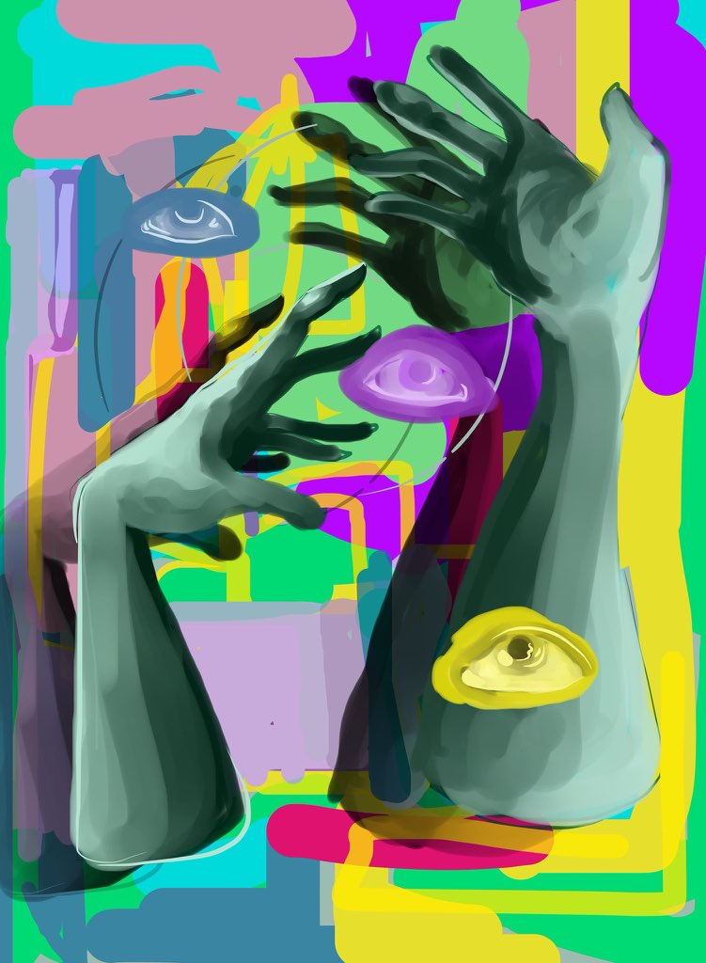

**Imagery**

Medium: Paint, graphic design

Imagery: Geometric, eyes, hands, realistic aspects, slightly abstract

Shapes are the body figures, some which are more discrete than others, and some geometric shapes

**Compositional Preferences**

I believe that the focal point is the purple eye in between the two hands. The hands provide direction for the viewer towards the eye and sort of frame the central region of the piece. The background colors also frame this area. There is balance created in the piece from the duality of the two hands taking up the two vertical halves of the piece and the three eyes located in each of the three horizontal sectors.

**Depth**

Depth is created through the shading of the hands onto the background, thus making it seem the hands are above the background. The eyes appear to be flat upon the image, not nestled within the space necessarily.

**Color**

The colors are all very high key, high saturation, and very bright. The hands are cooler colors but are still vibrant. They help even out and provide color balance to the extravagant background.

Image 24:

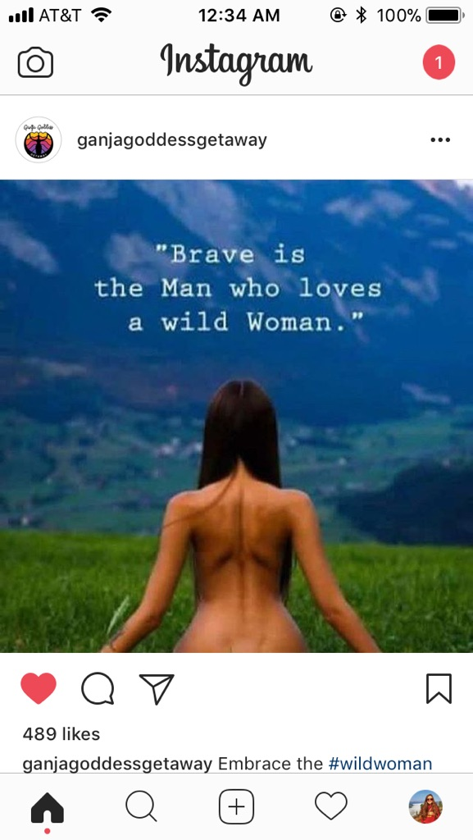

**Imagery**

Medium: Photo

Imagery: Realist, Nature, Human, Writing

Shapes: Human body, mountains in background, town, grass(straight lines)

**Compositional Preferences**

The woman is the focal point because she is the brightest, warmest color and is forefront in the image. She is emphasized because nothing else in the image is human and the writing references her(“wild Woman”). There is balance created because of the symmetry. The left side of the image is almost the exact same as the right side, discounting the far background and its slight differences.

**Depth**

Depth is created because, for once, I actually chose an image with a background. The woman looks to be looking out into space (towards the mountain and a city). You can see the atmospheric perspective in the piece because the background is low contrast. It also is less detailed and less vibrant, thus creating depth.

**Color**

The colors used primarily are green, blue, brown, and tan. All colors are very high key with high saturation, discounting the far background where atmospheric perspective is causing the colors to be duller and less contrasted. There is color balance within the image because the closer up features are so bright compared to the farther away stuff, it creates a sort of symmetry and balance.

Image 25:

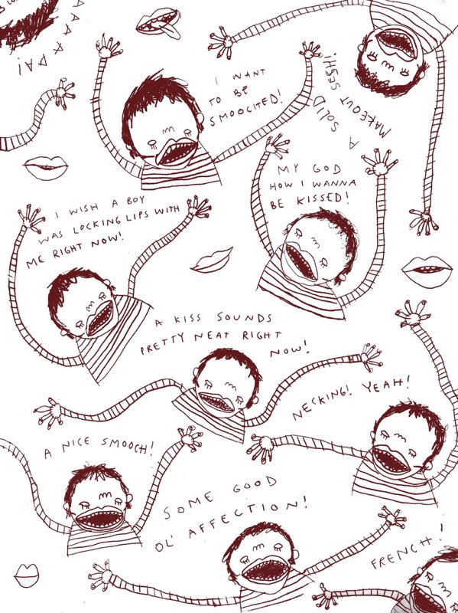

**Imagery**

Medium: Drawing/Ink

Imagery: Realist, Humans, Writing , Line drawing

Shapes: Organic human arms, hands, and bodies, writing

**Compositional Preferences**

No one focal point. The human heads are emphasized because of their contrast in color in their hair and mouths. The arms help to balance out the piece and provide directional forces/a tool for movement throughout the drawing. There is unity within the drawing because of the repetition of bodies and the sayings; they are all talking about kissing and wanting to be kissed.

**Depth** (What kind of depth? How is it being created?):

There is no depth in this piece, it’s flat. Since it is a line drawing with no background with no objects going back into space it looks as though all of the humans are on the same plane with the words in a sort of “white space” dimension.

**Color**

The only colors used is a dark burgundy and the white background. This is a line drawing, so the focus is in the details not in the color. The color scheme could be thus considered monochromatic because white is technically just a tint.

Image 26:

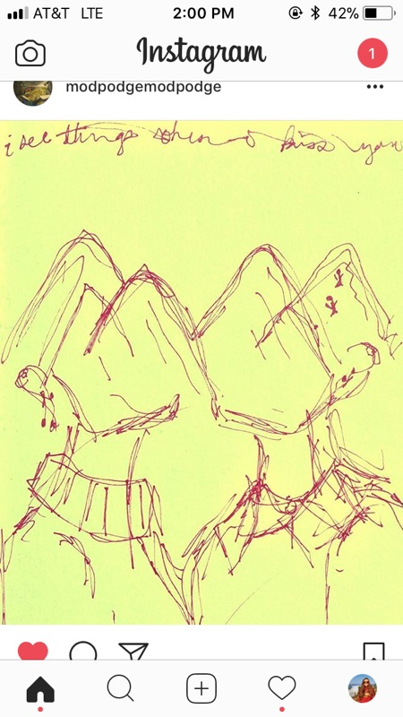

**Imagery**

Medium: Drawing

Imagery: Realist, Nature, Humans, Expressive, Writing, Line Drawing

Shapes: organic humans, geometric free-form mountains, writing/lettering

**Compositional Preferences**

The focal point is the mountain heads. There is balance within the piece in the symmetry. There are two humans, 4-6 mountains and there are generally very similar, other than the fact that one is women and one is man; this in a way also adds to the balance having one human of each gender. Movement is created in the piece from the lines of the mountains intersecting and coming together in the center of the piece- thus pulling together the two halves of the pictures and the two people. The mountains appear to be together, as one mountain range, so the movement in lines help the eye across the image and helps the viewer to pull together the full picture.

**Depth**

This image is primarily flat, it has no background and is a line drawing. There is some depth created within the overlap of the two humans, but it is definitely subtle.

**Color**

The color scheme is just the dark red and the bright yellow-green background. The contrast between these colors create emphasis on the actual image and the detail within the lines.

Image 27:

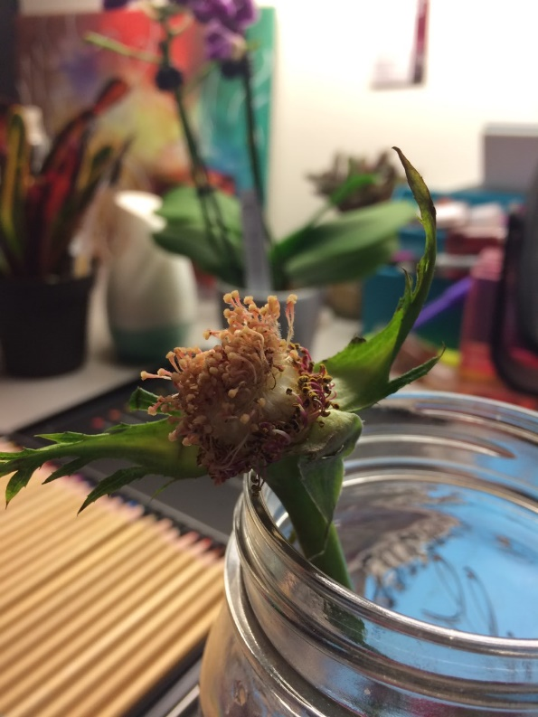

**Imagery**

Medium: Photo

Imagery: Realist, Nature,

Shapes: organic protrusions from the bulb, geometric/rigid looking leaves stemming from the stalk.

**Compositional Preferences**

The focal point is the ovary of the rose. (Googled technical term) This is an image of the inside of a wilted rose that I took. You can tell this is the focal point of the piece because of the focus and detail being centralized on one specific part of the photo- the head of the flower.

**Depth**

There is depth created in the image because of the blurring of the background and the lack of detail and clarity behind the focal area- the flower head. You can see the pencils on the desk behind the flower going back into space and getting smaller and harder to distinguish; a clear definer of depth.

**Color**

There is a lot of high key, saturated color in this photo. The brighter colors are found in the background with the flowers, painting, and colored pencils, however they are blurred and dulled to juxtapose and highlight the focal point colors.

Image 28:

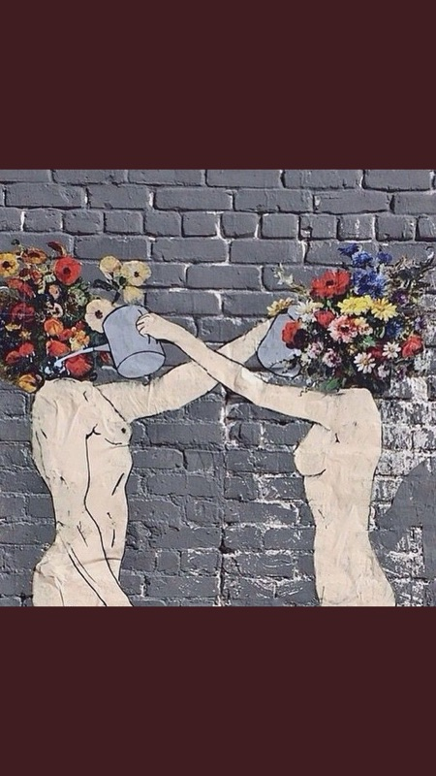

**Imagery**

Medium: Painting

Imagery: Realist, Nature, Humans, Floral

Shapes: Geometric bricks, flowers, organic human bodies

**Compositional Preferences**

The focal points in this piece are the flower heads. There is symmetrical balance in the piece from the similarity of the two sides of the image; there are two humans with the same colored bodies with proportional flower heads. There is movement in the piece from the water flowing into the flowerheads, thus creating more emphasis on the focal point. The overlapping of the two arms create unity and cohesiveness within the piece.

**Depth**

The image is generally pretty flat as there is no background other than the grey wall. There is some implied depth created from the overlap of the two arms and the detail within the bodies, implying a 3-d nature.

**Color**

Everything is pretty dull/neutral colors other than the focal points, which are brightly colored and stand out considerably. There is balance created within the colors divided on either side of the image. There is depth created within the flower colors because towards the back of the bouquet it gets darker and less defined.

Image 29:

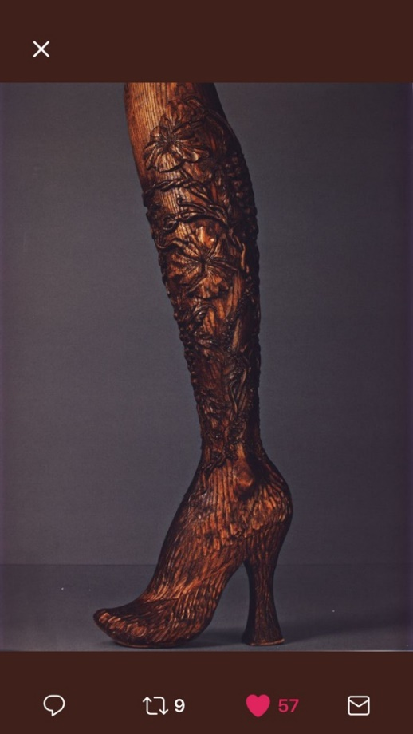

**Imagery**

Medium: Woodwork

Imagery: Realist, Nature, floral

Shapes: organic flowers and lines carved into wood

**Compositional Preferences**

The focal point for this piece is probably the foot/heel with the directional lines leading upward on the leg. They slowly progress to flowers and bigger shapes, thus creating balance from the elegance of the foot to the intricacies of the leg.

**Depth** (What kind of depth? How is it being created?):

The depth is actual depth, because this piece is 3d. It is created because this piece was carved out of wood and has actual depth in its features and details because it is carved.

**Color**

The only colors really used for the piece were natural stains of goldish brown and dark brown. Not adding more colors helped emphasize the details and didn’t overcomplicate the work. The lighter colors on the foot are balanced with the darker colors outlining the flowers going up the legs.

Image 30:

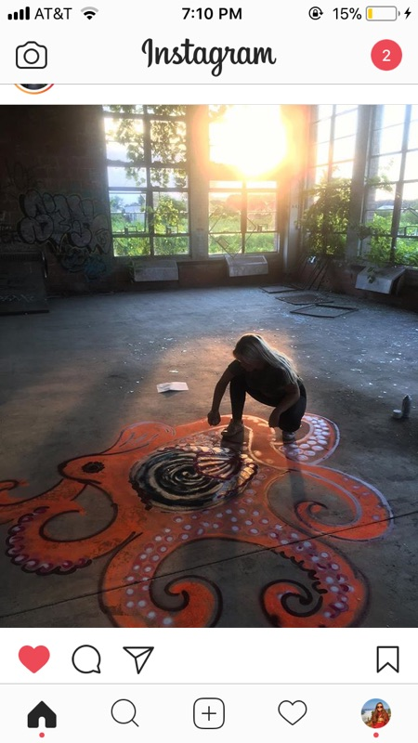

**Imagery**

Medium: Spray Paint

Imagery: Realist, Nature, Abstract, Line drawing

Shapes: Organic/free formed octopus with circular geometric design in center

**Compositional Preferences**

The focal point is, I am assuming, the center of the octopus. It looks the darkest and has the most contrast, thus creating emphasis. Balance is created by the multiple freeflowing octopus arms and the curves evening out the shape of the body. There are no directional forces applies, but generally if you follow the arms you get to the focal point so there are implied directional forces.

**Depth**

This piece is flat, with no specific use of overlap, shading, or other depth-creating factors. The artist was not trying to make this octopus look realistic, per say. More an abstract, flat, octopus with focus on the free-flowing nature and underlying details of color and design within the arms.

**Color**

They are using the primary color scheme of orange, and purple, and red, with tints of white and silver. All these colors are on one portion of the color wheel so is thus consider analogous. The colors are warm with high saturation and are high-key, straight out of the spray can. The orange is the primary color and the purple adds detail and thus bits of depth and realistic-ness to the octopus.